USER MANUAL
Malaysian FinTech eWallet Sentiment Analyser
Aspect-Based Sentiment Analysis of Malaysian eWallet Applications
Course | TNL6323 Natural Language Processing
Domain | Technology (Malaysia Tech Scene) - Financial Technology
Applications | Touch 'n Go eWallet, GrabPay and ShopeePay
Interface | Streamlit web application with ONNX Runtime

Group member | ID
Sia Poh Xiang | 1211108363
Lim Chin Chen | 1211108626
Shi Hong Yi | 1211108962
Joshua Wong Yong | joshua.wong.yong

1. System Overview
The Malaysian FinTech eWallet Sentiment Analyser is a local review-analysis system developed for the Technology (Malaysia Tech Scene) domain. It analyses English and Bahasa Malaysia reviews for Touch 'n Go eWallet, GrabPay and ShopeePay. One dual-head multilingual BERT model produces an overall sentiment label and one dominant aspect label in a single inference pass.

1.1 Main Functions
- Classify a single review as positive, neutral or negative.
- Identify the dominant aspect: payment, user interface, customer service, rewards or general feedback.
- Display confidence values for sentiment and aspect predictions.
- Detect emojis and show an auxiliary emoji-tone signal.
- Present dataset-level sentiment and aspect visualisations for three Malaysian eWallet applications.
- Provide a project information page containing the Technology domain, methodology, dataset and model metrics.

1.2 Important Interpretation Note
The dashboard dataset is intentionally balanced. Each application contains 220 positive, 220 neutral and 220 negative reviews. Therefore, the dashboard must not be used to claim that one application has a higher natural positive-review rate than another. Aspect predictions with low confidence should be treated as exploratory suggestions.

2. System Requirements
Item | Requirement / Recommendation
Operating system | Windows 10 or Windows 11 recommended; other systems may work with equivalent Python commands.
Python | Python 3.10 recommended.
Memory | At least 8 GB RAM recommended because the ONNX model is approximately 679 MB.
Storage | At least 2 GB free space for the project, model and dependencies.
Internet | Required for initial package installation only. Application inference is local when all files are present.
Browser | A modern browser such as Chrome, Edge or Firefox.

2.1 Required Project Files
Lab1D-G1/
├── Data/
│ ├── sentiment_data_absa_labeled.csv
│ └── charts/
│ ├── wordcloud_positive.png
│ ├── wordcloud_neutral.png
│ └── wordcloud_negative.png
├── Models/
│ ├── mbert_model.onnx
│ ├── mbert_tokenizer/
│ └── model_results.txt
└── Source Codes/
├── app.py
└── requirements.txt
The application uses relative paths. Keep the folders at the same hierarchy shown above.

3. Installation and Setup
1. Extract the submission archive - Place the extracted folder in a location with sufficient free space.
2. Open Command Prompt, PowerShell or Anaconda Prompt - Navigate to the project root folder, not directly to the Source Codes folder.
cd "C:\Path\To\Lab1D-G1"
3. Create a virtual environment (recommended)
py -3.10 -m venv .venv
.venv\Scripts\activate
4. Install project dependencies
python -m pip install --upgrade pip
python -m pip install -r "Source Codes\requirements.txt"
5. Confirm the required files
- Models/mbert_model.onnx exists.
- Models/mbert_tokenizer/ contains tokenizer files.
- Models/model_results.txt exists.
- Data/sentiment_data_absa_labeled.csv exists.
- Data/charts/ contains the three word-cloud images.

3.1 Start the Application
python -m streamlit run app.py
Streamlit normally opens the system automatically in the default browser. If it does not, copy the Local URL shown in the terminal, usually http://localhost:8501, and open it in a browser.

4. Using the Sentiment Analyser
1. Select Sentiment Analyser from the left navigation panel.
2. Enter one eWallet review - English and Bahasa Malaysia are supported. The review should describe an eWallet experience.
3. Select the relevant eWallet application.
4. Click Analyse Sentiment.
5. Review the outputs - The system displays sentiment, sentiment confidence, dominant aspect, aspect confidence, combined insight and any detected emojis.
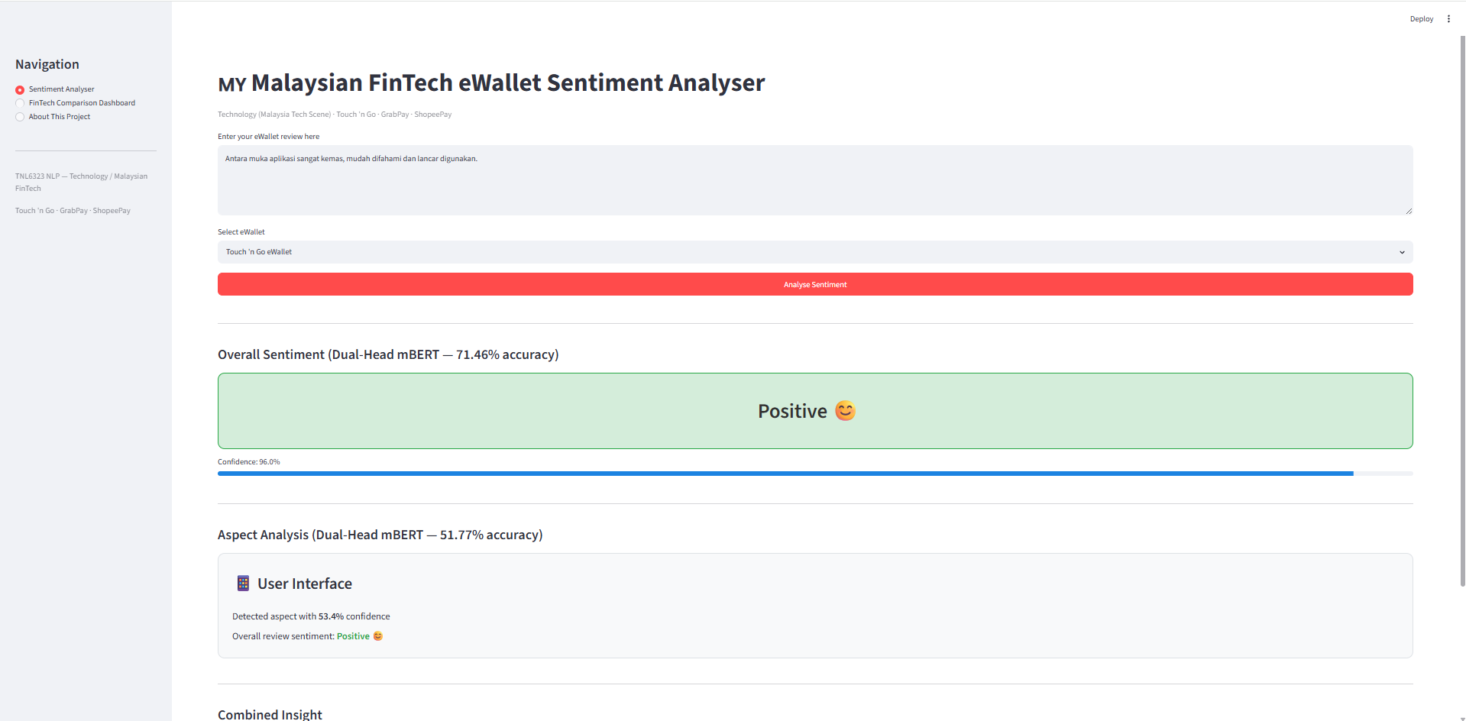
Figure 1. Example Bahasa Malaysia review classified as Positive with User Interface as the dominant aspect.

4.1 Interpreting the Result
Output | Meaning
Overall Sentiment | The predicted review-level polarity: positive, neutral or negative.
Sentiment Confidence | The model probability assigned to the selected sentiment class.
Aspect Analysis | The single dominant category predicted for the review.
Aspect Confidence | The model probability assigned to the selected aspect category.
Low-confidence warning | Shown when aspect confidence is below 50%; the result should be treated cautiously.
Combined Insight | A plain-language summary combining the selected application, sentiment and aspect.
Emoji Signal | An auxiliary rule-based tone indicator; it does not replace the mBERT prediction.

4.2 Suggested Test Reviews
Payment - Positive: The payment and reload process is fast, reliable, and completes instantly every time.
Payment - Negative: Pembayaran dan tambah nilai selalu gagal walaupun baki saya mencukupi.
User Interface - Positive: Antara muka aplikasi sangat kemas, mudah difahami dan lancar digunakan.
Service - Negative: Customer service took a week to reply and still did not resolve my account problem.
General - Neutral: The eWallet provides the standard functions I expected; nothing was especially good or bad.

5. Using the FinTech Comparison Dashboard
Select FinTech Comparison Dashboard from the left navigation panel. The page includes:
- Total reviews analysed.
- Balanced reviews per application.
- Most complained aspect in the balanced corpus.
- Sentiment distribution by eWallet application.
- Aspect distribution by eWallet application.
- Aspect-sentiment heatmap.
- Positive, neutral and negative word clouds.
- An automatically generated dataset summary that avoids positive-rate rankings.
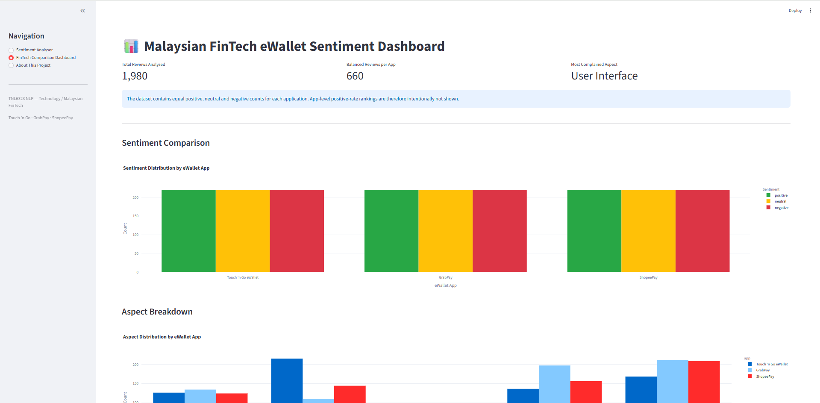
Figure 2. Malaysian FinTech eWallet dashboard showing balanced review counts and aspect distributions.
Important: the three sentiment bars have equal heights by design because the final dataset contains 220 reviews for each sentiment class within every application. The dashboard supports controlled comparison of aspect distributions, not a claim that one eWallet is naturally more positive than another.

6. Using the About This Project Page
Select About This Project to view the following sections:
- Project Overview - Technology (Malaysia Tech Scene) and Financial Technology positioning.
- Dataset Information - source, applications, size, language and labelling methods.
- Methodology - data collection, preprocessing, aspect labelling, dual-head model and deployment.
- Advanced Features - mBERT, zero-shot aspect labelling, ABSA, emoji detection, ONNX and multilingual support.
- Group Members - the four project members.
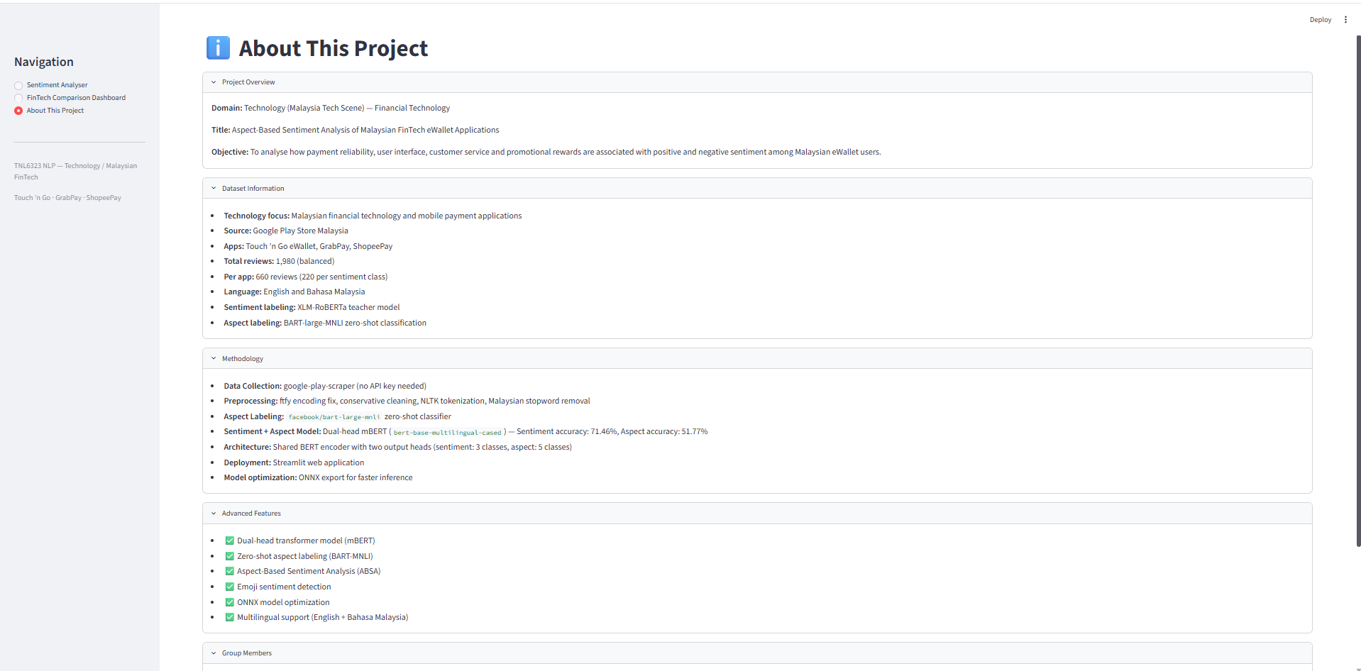
Figure 3. Technology-aligned project overview, dataset information, methodology and advanced features.

7. Troubleshooting
Problem | Likely Cause | Action
ModuleNotFoundError | A required package is missing or the wrong Python environment is active. | Activate the intended environment and reinstall requirements.txt.
Model files not found | The ONNX model or tokenizer folder is missing or placed at the wrong level. | Restore the ONNX model and tokenizer under the Models folder.
Dataset not found | The labelled CSV is missing or the folder hierarchy changed. | Restore the labelled CSV under the Data folder.
Word cloud not found | The PNG files were not copied or preprocessing was not run. | Restore the word-cloud PNGs under Data/charts or run preprocess.py.
Port 8501 is already in use | Another Streamlit session is still running. | Close the old terminal or start Streamlit on another port, such as 8502.
Slow first load | The approximately 679 MB ONNX model is being loaded into memory. | Wait for the model to load; subsequent predictions should be faster.
Low aspect confidence | The aspect head is uncertain, particularly for minority or overlapping categories. | Treat the aspect as exploratory and review the text manually.

7.1 Stop the Application
Return to the terminal that is running Streamlit and press Ctrl+C. Close the browser tab after the server stops.

8. Operational Limitations
- The system predicts one dominant aspect per review and does not independently score several aspects in the same review.
- Aspect accuracy is lower than sentiment accuracy, and the rewards class is underrepresented.
- Pseudo-labels are not human-annotated gold labels.
- The balanced dataset is suitable for controlled training and demonstration but not for natural market-share or app-satisfaction ranking.
- Sarcasm, implicit sentiment, unusual spelling and highly mixed-language reviews may be difficult.
- The application is an academic prototype and should not be treated as a production-grade decision system.

9. Quick Command Reference
# Open the project folder
cd "C:\Path\To\Lab1D-G1"
# Activate the optional virtual environment
.venv\Scripts\activate
# Install dependencies
python -m pip install -r "Source Codes\requirements.txt"
# Run the application
python -m streamlit run "Source Codes\app.py"
# Stop the application
Press Ctrl+C in the terminal
Submission verification: Confirm that the final archive contains the Data folder, Source Codes folder, ONNX model, tokenizer, report, this user manual, contribution form and demo video. Technical issues should first be checked against the folder structure and troubleshooting table in this manual.

